# Analysis of Israeli restaurants in New York City

## Ela Markovsky Capstone Project

## Introduction

The 2000 United States Census estimated that as many as 106,839 Israelis live in the United States, while other unsourced estimates say the number is much higher, around 500,000[1]. New York City is the city where most Israeli-Americans reside[2]. Immigrants tend to bring their cuisine with them and Israelis are no exception, evidenced by new Israeli restaurants constantly popping up in New York City[3].

In this project I plan to analyze Israeli restaurants in New York City and obtain the number of restaurants by borough, their ratings and the number of ratings they receive. This analysis would be valuable to people who consider opening a restaurant serving Israeli cuisine. This analysis will help determine whether there is a sufficient demand for such restaurants and in which borough it would be best to open one. This analysis would also be of interest to Israeli-Americans and anyone who enjoys Israeli cuisine.

## Data

Data on names and locations was collected from Foursquare by making a basic request for restaurants labeled as “Israeli”.

## Methodology

Data was imported and analyzed using Python and pandas library. Data was visualized using matplotlib and folium libraries. The request was made using latitude and longitude of NYC with a radius of 15000. Foursquare location data for a restaurant does not include the borough, therefore a separate dataset (<https://www.health.ny.gov/statistics/cancer/registry/appendix/neighborhoods.htm>), was used to assign each restaurant to the borough according to its zip code. Restaurants that were not in any borough were dropped from the analysis using dropna function. This removed several restaurants in New Jersey that were included in the initial request because they were inside the radius. The number of Israeli restaurants in each borough was obtained using value.counts() function.   
 A separate premium request was made for each restaurant to get their rating and number of ratings. These ratings were saved to avoid making multiple premium requests. Average rating and average number of ratings for all Israeli restaurants and for restaurants in each borough was calculated using the mean() function. These results were visualized using matplotlib.pyplot bar graphs. Top ten rated restaurants were obtained by sorting the dataframe in descending order and using the head(10) functions.   
Finally, locations, names and ratings of the restaurants were visualized on NYC map using folium.map. Markers were color coded according to the rating of the restaurant.

## Results

**Number of restaurants in each borough**

|  |  |
| --- | --- |
| Manhattan | 63 |
| Brooklyn | 20 |
| Queens | 2 |
| Bronx | 0 |
| Staten Island | 0 |

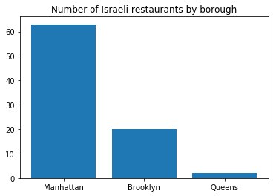

Figure – Number of Israeli restaurants in NYC in each borough

### **Average ratings**

Average rating of all Israeli restaurants in NYC was 8.1

### **Average ratings by borough:**

|  | **Rating** | **No. of Ratings** |
| --- | --- | --- |
| **Brooklyn** | 8.1 | 507 |
| **Manhattan** | 8.1 | 430 |
| **Queens** | 7.5 | 206 |

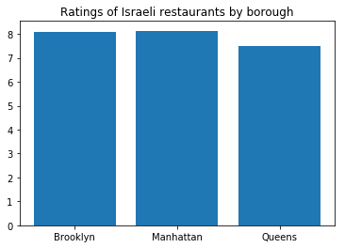

Figure – Average rating of Israeli restaurants in each borough

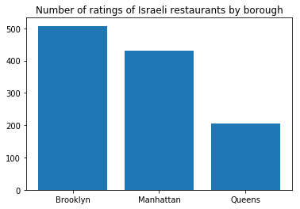

Figure - – Average number of ratings for Israeli restaurants in each borough

### Visualization of restaurants on NYC map

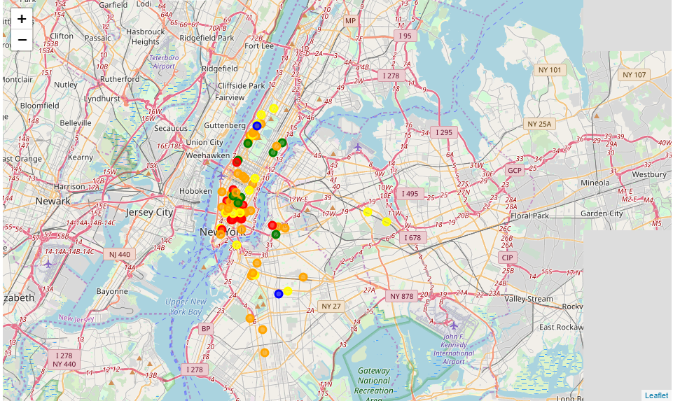

Figure – Israeli restaurants marked on NYC map. Color of markers corresponds to rating (red: >= 9.0, orange: between 9.0 and 8.0, yellow: : between 8.0 and 7.0, green: : between 7.0 and 6.0, blue: < 6.0)

## Discussion

This report reveals that most Israeli restaurants are in Manhattan, despite the large Israeli populations in Brooklyn and Queens. Israeli restaurants are usually highly rated (average rating 8.1) and there is no significant difference in rating between boroughs. However, these was a substantial difference in number of ratings, which can be translated to number of visitors. Restaurants in Brooklyn had the most ratings on average, and Queens had the least. Based on these data I would recommend to open a new restaurant in Brooklyn, since there are much less restaurants there than in NYC, meaning a less saturated market, while there is a large Israeli population there. Moreover, restaurants in Brooklyn usually get a large number of ratings, which can be translated into a large number of visitors. Therefore, opening a restaurant in Brooklyn has the most potential.

### Conclusions

This report analyzed Israeli restaurants in New York City using Foursquare data. Number of restaurants by borough and ratings were analyzed.

## References

1. <https://en.wikipedia.org/wiki/Israeli_Americans>
2. <https://factfinder.census.gov/faces/tableservices/jsf/pages/productview.xhtml?pid=DEC_00_110S_QTP13&prodType=table>
3. <http://www.grubstreet.com/2017/06/rise-of-israeli-cuisine-in-new-york.html>